Data Interpretation Exercise_CO1_AT2

Done by: Yeshwanth.A (192524013)

Question 1: Mapping Data onto Aesthetics
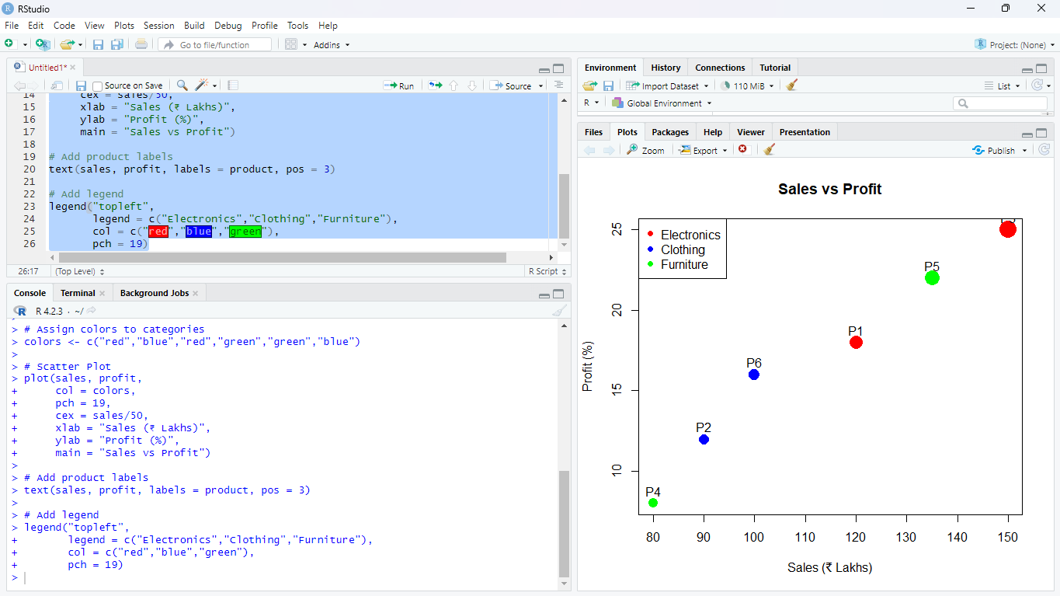
- Write an R program to create a scatter plot with Sales on the x-axis and Profit on the y-axis.
library(ggplot2)
product <- c("P1","P2","P3","P4","P5","P6")
sales <- c(120,90,150,80,135,100)
profit <- c(18,12,25,8,22,16)
category <- c("Electronics","Clothing","Electronics","Furniture","Furniture","Clothing")

data <- data.frame(product, sales, profit, category)

ggplot(data, aes(x = sales, y = profit,
color = category,
size = sales)) +
geom_point() +
geom_text(aes(label = product), vjust = -1) +
labs(title = "Sales vs Profit",
x = "Sales (₹ Lakhs)",
y = "Profit (%)") +
theme_minimal()

ii.) Map Category using an appropriate aesthetic and Sales using another suitable aesthetic.
Answer:
- Category → Color
- Sales → Size of the points
This makes it easy to distinguish product categories while showing sales magnitude.

iii.) Interpret the relationship between Sales and Profit.
Answer:
The scatter plot shows a positive relationship between Sales and Profit. Products with higher sales generally have higher profit percentages. For example, P3 has the highest sales (₹150 Lakhs) and the highest profit (25%), while P4 has the lowest sales (₹80 Lakhs) and the lowest profit (8%).

iv.) Identify the type of scale used for each variable.
Variable | Scale Type
Product | Nominal
Sales | Continuous (Numeric)
Profit | Continuous (Numeric)
Category | Nominal (Categorical)

v.) Suggest one alternative visualization that better represents the same data.
Answer:
A Bubble Chart is a good alternative visualization. It represents:
- Sales on the x-axis,
- Profit on the y-axis,
- Category using different colors,
- Sales (or Profit) using bubble size.
It provides a clear comparison of all variables in a single chart

Question 2: Coordinate Systems (Cartesian and Polar)

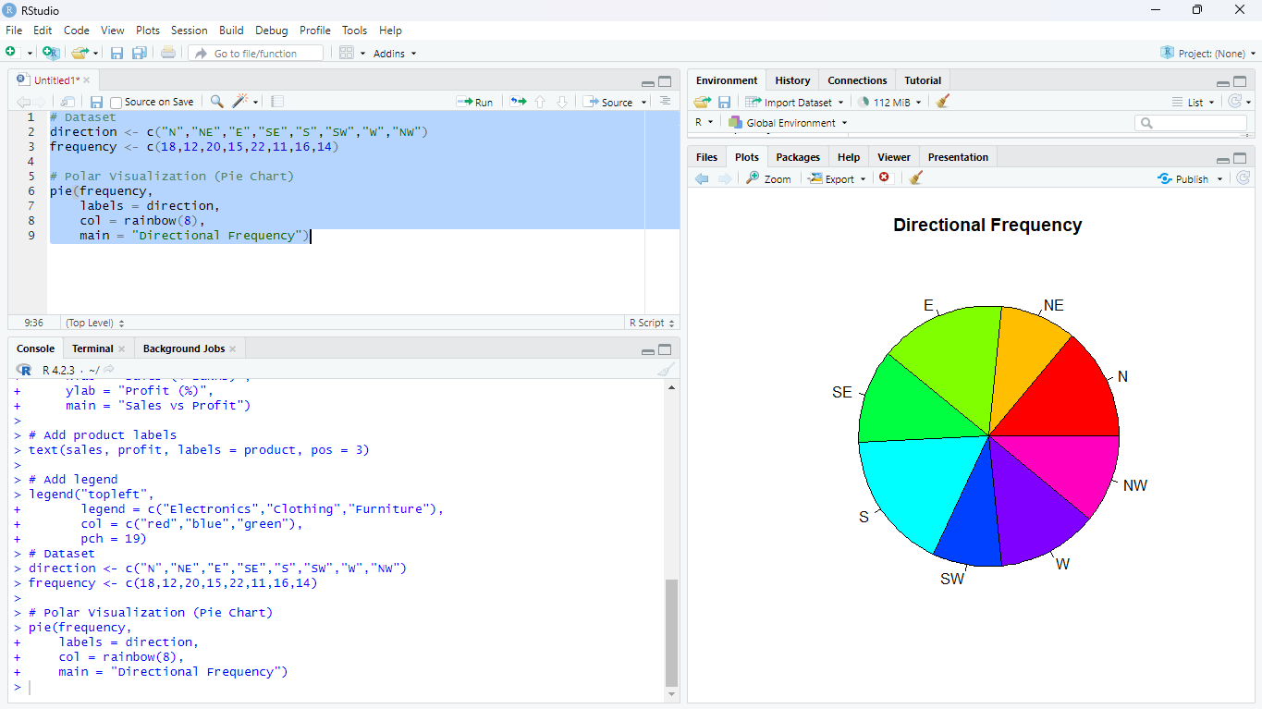

- Write an R program to visualize the dataset using a Cartesian coordinate system.

direction <- c("N","NE","E","SE","S","SW","W","NW")
frequency <- c(18,12,20,15,22,11,16,14)

# Polar Visualization (Pie Chart)
pie(frequency,
labels = direction,
col = rainbow(8),
main = "Directional Frequency")

ii.) Write another R program to visualize the same data using a Polar coordinate system.
Answer:
The above pie chart represents the same data in a Polar coordinate system, where each slice corresponds to a direction and its frequency.

iii.) Compare the effectiveness of both visualizations.
Cartesian (Bar Plot) | Polar (Pie Chart)
Easier to compare frequencies accurately. | Better for showing proportions.
Values are clearly visible. | Gives an overall view of the data.
Suitable for precise comparisons. | Suitable for percentage distribution.

iv.) Explain which coordinate system is more appropriate for directional data.
Answer:
The Polar coordinate system is more appropriate for directional data because it naturally represents directions around a circle (N, NE, E, SE, S, SW, W, NW), making the visualization easier to understand.

v.) Justify your answer based on data interpretation.
Answer:
The polar visualization clearly shows the distribution of frequencies across all directions. Since directional data is circular in nature, the Polar coordinate system provides a more meaningful representation, while the Cartesian system is better for comparing exact frequency values.

Question 3: Color Scales for Data Representation
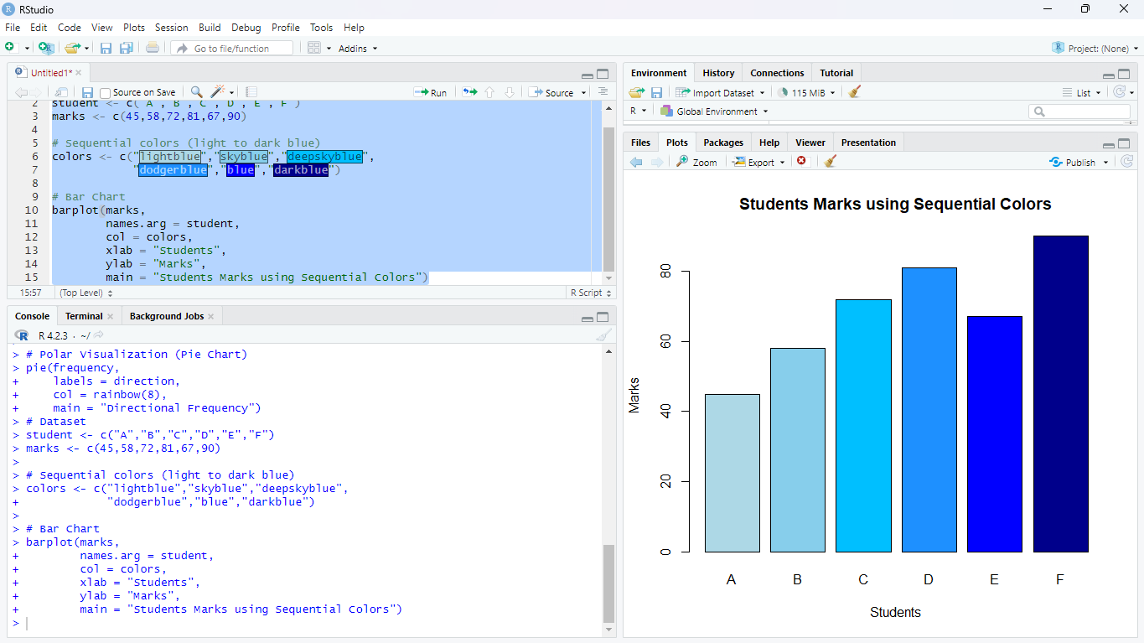

i.) R Program to Create a Bar Chart Using a Sequential Color Scale
# Dataset
student <- c("A","B","C","D","E","F")
marks <- c(45,58,72,81,67,90)

# Sequential colors (light to dark blue)
colors <- c("lightblue","skyblue","deepskyblue",
"dodgerblue","blue","darkblue")

# Bar Chart
barplot(marks,
names.arg = student,
col = colors,
xlab = "Students",
ylab = "Marks",
main = "Students Marks using Sequential Colors")

ii.) Identify the Students with the Highest and Lowest Marks
Answer:
- Highest Marks: Student F – 90 marks
- Lowest Marks: Student A – 45 marks
This can be clearly identified from the tallest and shortest bars.

iii.) Explain Why a Sequential Color Scale is Appropriate
Answer:
A sequential color scale is suitable because marks are numerical data that vary from low to high values. Using colors from light to dark helps in easily identifying lower and higher marks.

iv.) Suggest a Color Palette Suitable for Color-Blind Users
Answer:
A Blue color palette or Viridis palette is suitable for color-blind users because it provides clear contrast and is easy to distinguish.
Example colors:
- Light Blue
- Sky Blue
- Blue
- Dark Blue

v.) Explain the Difference Between Sequential and Categorical Color Scales
Sequential Color Scale | Categorical Color Scale
Used for numerical data | Used for categories
Colors change gradually | Different colors for each category
Shows order or magnitude | Shows distinct groups
Example: Marks | Example: Gender, Department

Question 4: Highlighting with Color

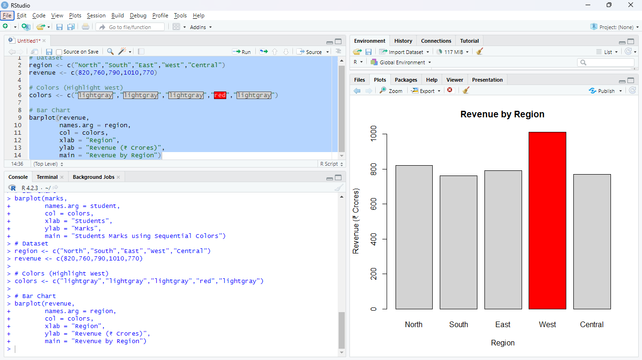

i.) R Program to Create a Bar Chart Highlighting the Highest Revenue
# Dataset
region <- c("North","South","East","West","Central")
revenue <- c(820,760,790,1010,770)

# Colors (Highlight West)
colors <- c("lightgray","lightgray","lightgray","red","lightgray")

# Bar Chart
barplot(revenue,
names.arg = region,
col = colors,
xlab = "Region",
ylab = "Revenue (₹ Crores)",
main = "Revenue by Region")

ii.) Explain How Highlighting Improves Data Interpretation
Answer:
Highlighting draws attention to important data points. It helps users quickly identify the highest-performing region without examining every value.

iii.) Identify the Highest-Performing Region
Answer:
The West region has the highest revenue of ₹1010 Crores.

iv.) Discuss How Excessive Use of Colors Can Affect Interpretation
Answer:
Using too many colors can make the chart confusing and distract the viewer. It becomes difficult to identify the most important information.

v.) Suggest One Alternative Highlighting Technique Other Than Color
Answer:
An alternative technique is adding data labels (showing the revenue values on top of the bars). This makes the important values easy to identify without relying on color.

Question 5: Integrated Visualization

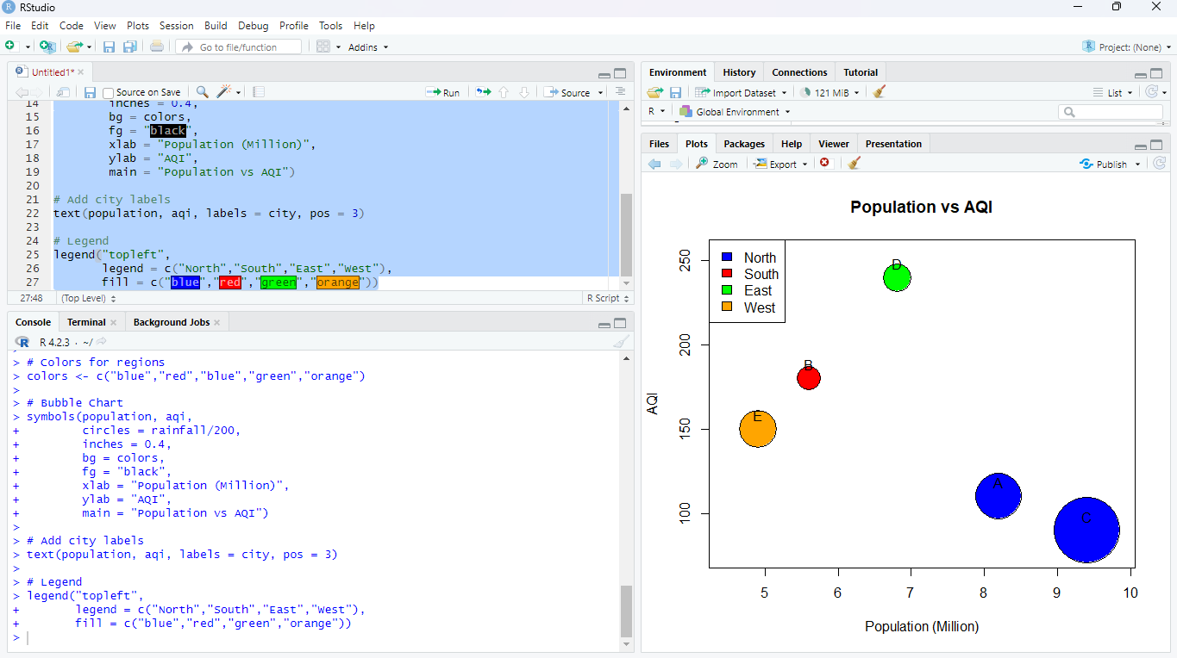

i.) Write an R program to create a bubble chart using appropriate aesthetic mappings.

# Dataset
city <- c("A","B","C","D","E")
population <- c(8.2,5.6,9.4,6.8,4.9)
aqi <- c(110,180,90,240,150)
rainfall <- c(850,430,1200,520,680)
region <- c("North","South","North","East","West")

# Colors for regions
colors <- c("blue","red","blue","green","orange")

# Bubble Chart
symbols(population, aqi,
circles = rainfall/200,
inches = 0.4,
bg = colors,
fg = "black",
xlab = "Population (Million)",
ylab = "AQI",
main = "Population vs AQI")

# Add city labels
text(population, aqi, labels = city, pos = 3)

# Legend
legend("topleft",
legend = c("North","South","East","West"),
fill = c("blue","red","green","orange"))

ii.) Select suitable aesthetics for Population, AQI, Rainfall, and Region.
Answer:
Variable | Aesthetic
Population | X-axis
AQI | Y-axis
Rainfall | Bubble Size
Region | Color

iii.) Interpret the relationship between Population and AQI.
Answer:
The chart shows no strong relationship between Population and AQI. Some cities with higher populations have lower AQI, while others with smaller populations have higher AQI.

iv.) Identify the continuous and categorical variables.
Continuous Variables | Categorical Variables
Population | City
AQI | Region
Rainfall | —

v.) Recommend one improvement to enhance the visualization's readability.
Answer:
Add data labels (city names) to each bubble so that viewers can easily identify each city.

